Lab 5: IPTables

**Part A:**

**For outgoing traffic (from 10.20.111.0/24 to 10.10.111.0/24) - your internal machine should be able to communicate with the external network and the external machines without restrictions. For incoming traffic (from the 10.10.111.0/24 to the 10.20.111.0/24) - all incoming connection requests should be rejected with the following exceptions:**

**sudo iptables -A FORWARD -s 10.20.111.2 -d 10.10.111.0/24 -m state --state NEW,ESTABLISHED,RELATED -j ACCEPT**

**sudo iptables -A OUTPUT -s 10.20.111.0/24 -d 10.10.111.0/24 -m state --state NEW,ESTABLISHED,RELATED -j ACCEPT**

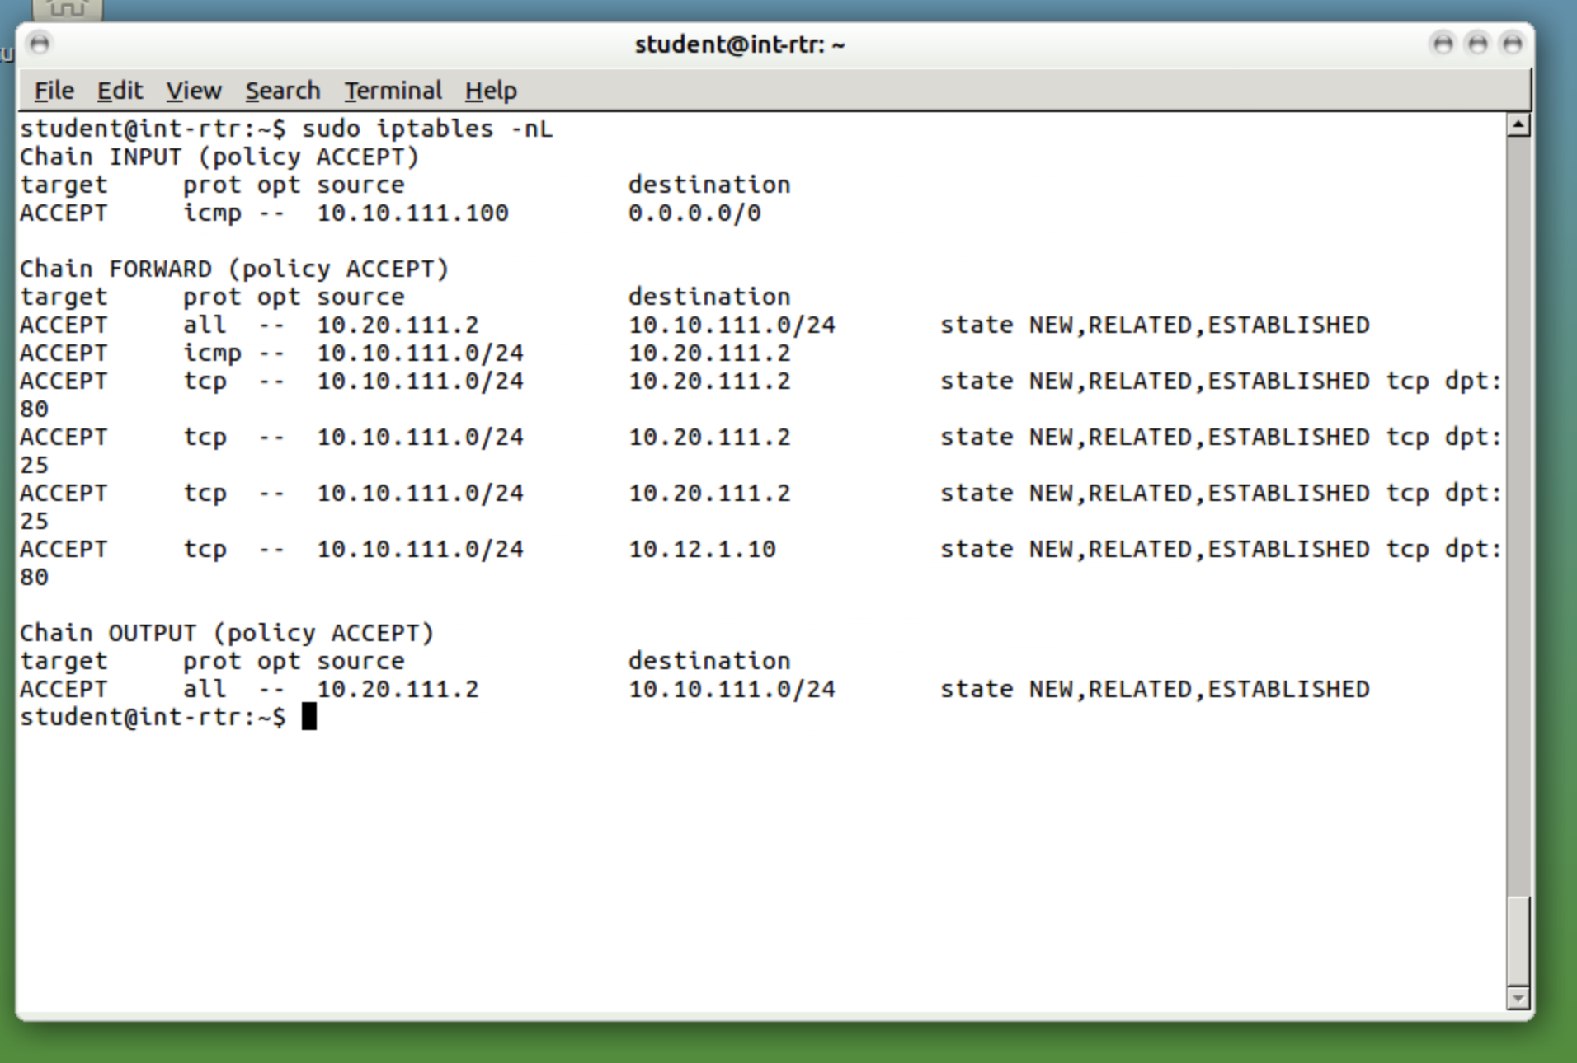

1. The internal machine should respond to a ping from 10.10.111.0/24

**sudo iptables -A FORWARD -s 10.10.111.0/24 -d 10.20.111.2 -p icmp -j ACCEPT**

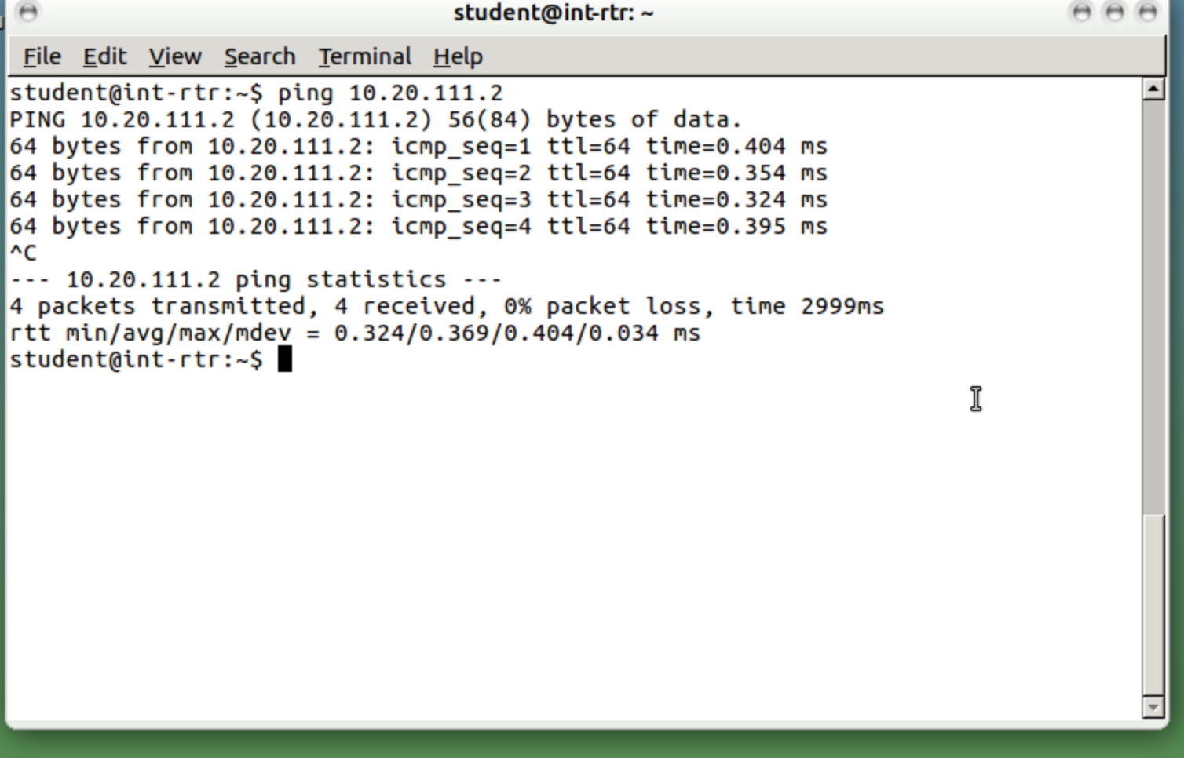

1. The internal machine (10.20.111.2) should accept all incoming SSH and SMTP (TCP 25) requests from 10.10.111.0/24. Hint: You can test SMTP by using the following netcat command: “nc [IP] 25” then type “HELO”.

**sudo iptables -A FORWARD -s 10.10.111.0/24 -d 10.20.111.2 -m state --state NEW,ESTABLISHED,RELATED -p tcp --dport 80 -j ACCEPT**

**sudo** **iptables -A FORWARD -s 10.10.111.0/24 -d 10.20.111.2 -m state --state NEW,ESTABLISHED,RELATED -p tcp --dport 25 -j ACCEPT**

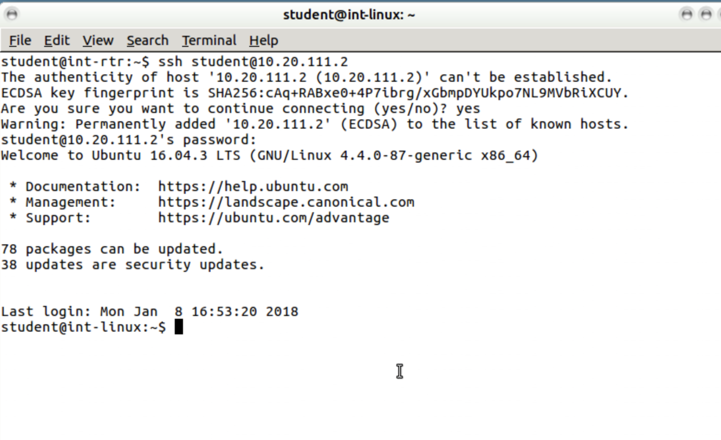

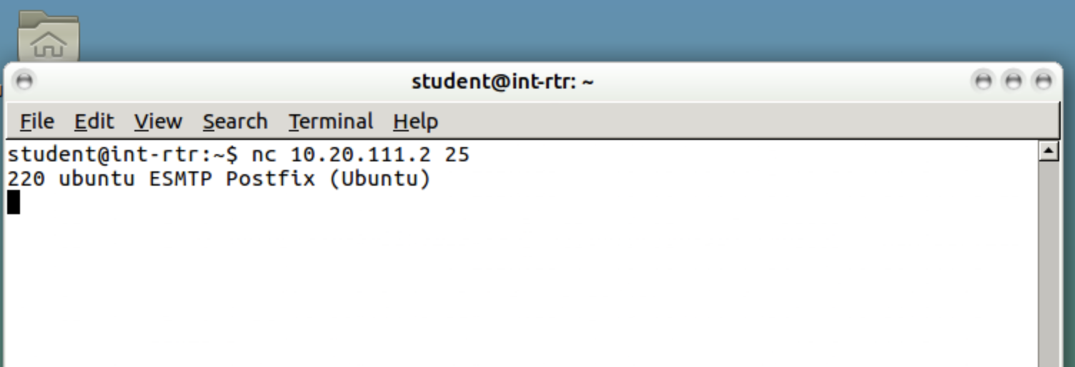

1. The internal machine should be able to perform a nslookup of fakebook.vlab.local

**sudo** **iptables -A FORWARD -s 10.20.111.0/24 -d 10.12.1.10 -m state --state NEW,ESTABLISHED,RELATED -p tcp --dport 80 -j ACCEPT**

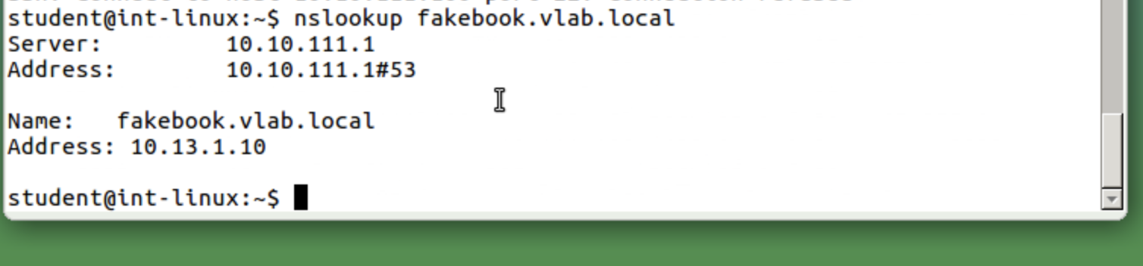

1. The internal router should accept pings from the Kali machine only

**sudo iptables -A INPUT -s 10.10.111.100 -p icmp -j ACCEPT**

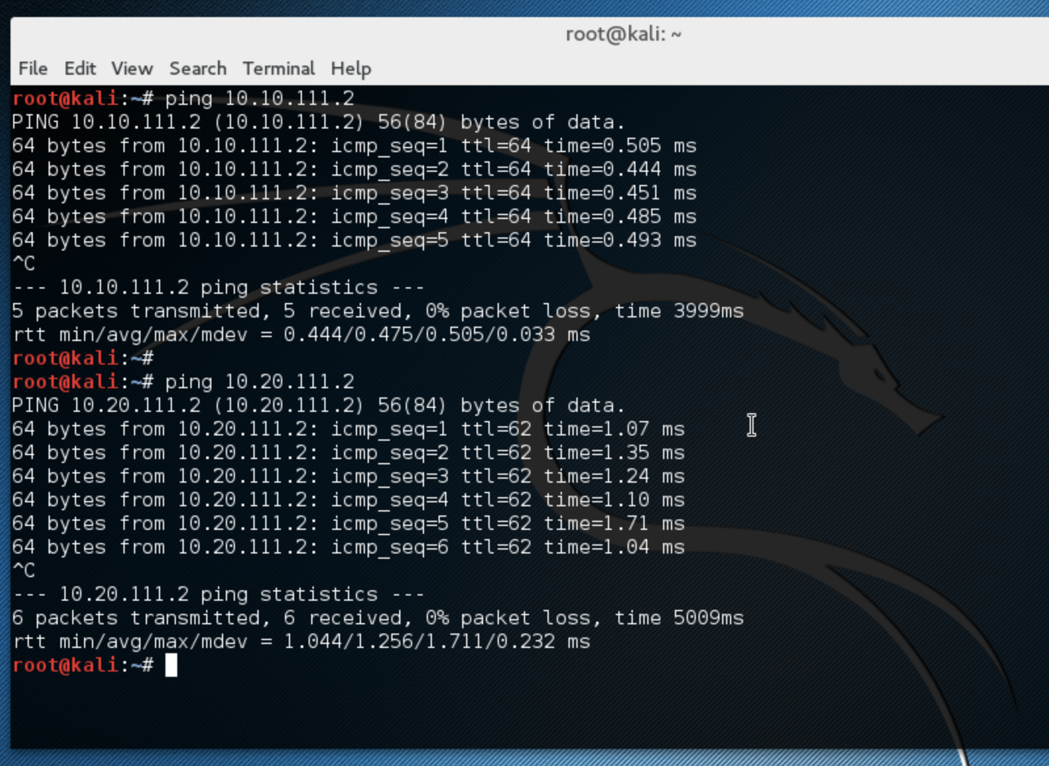

1. Proof for each attached in each question. More attached below

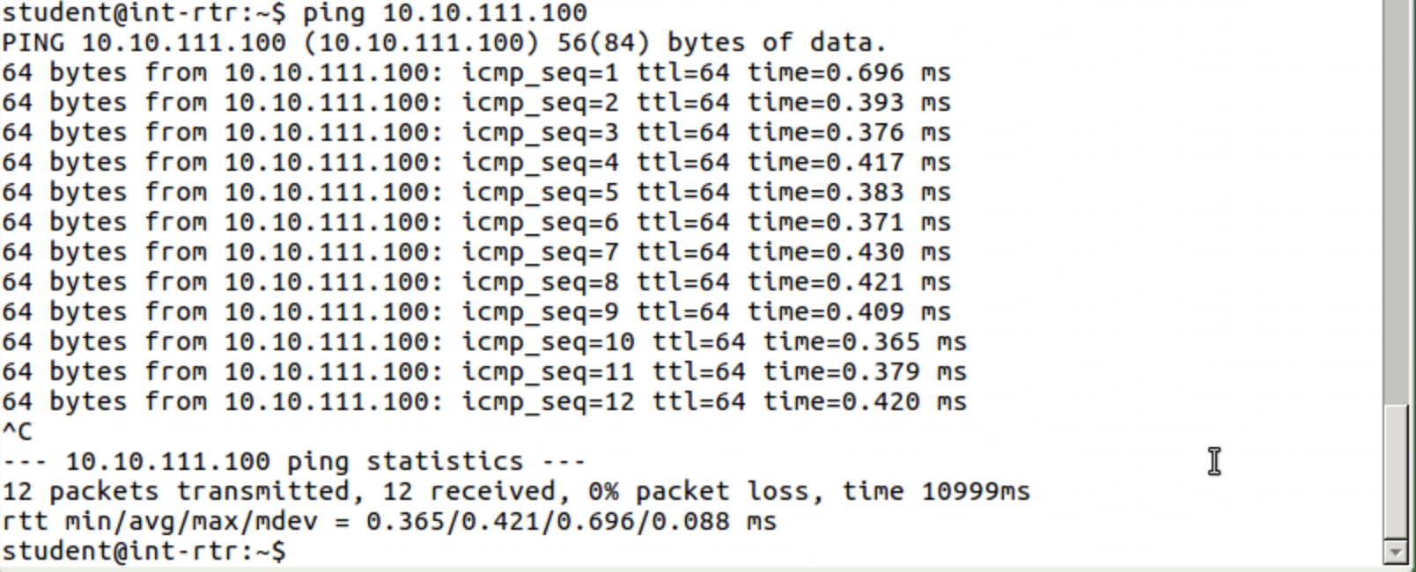

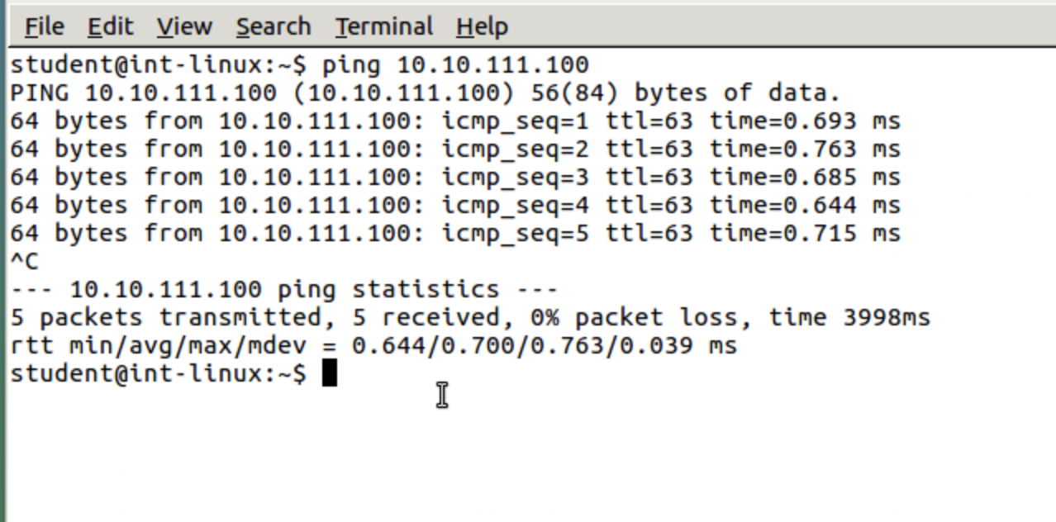

**PART B:**

**Sudo iptables -t nat -A POSTROUTING -o eth0 -j MASQUERADE**

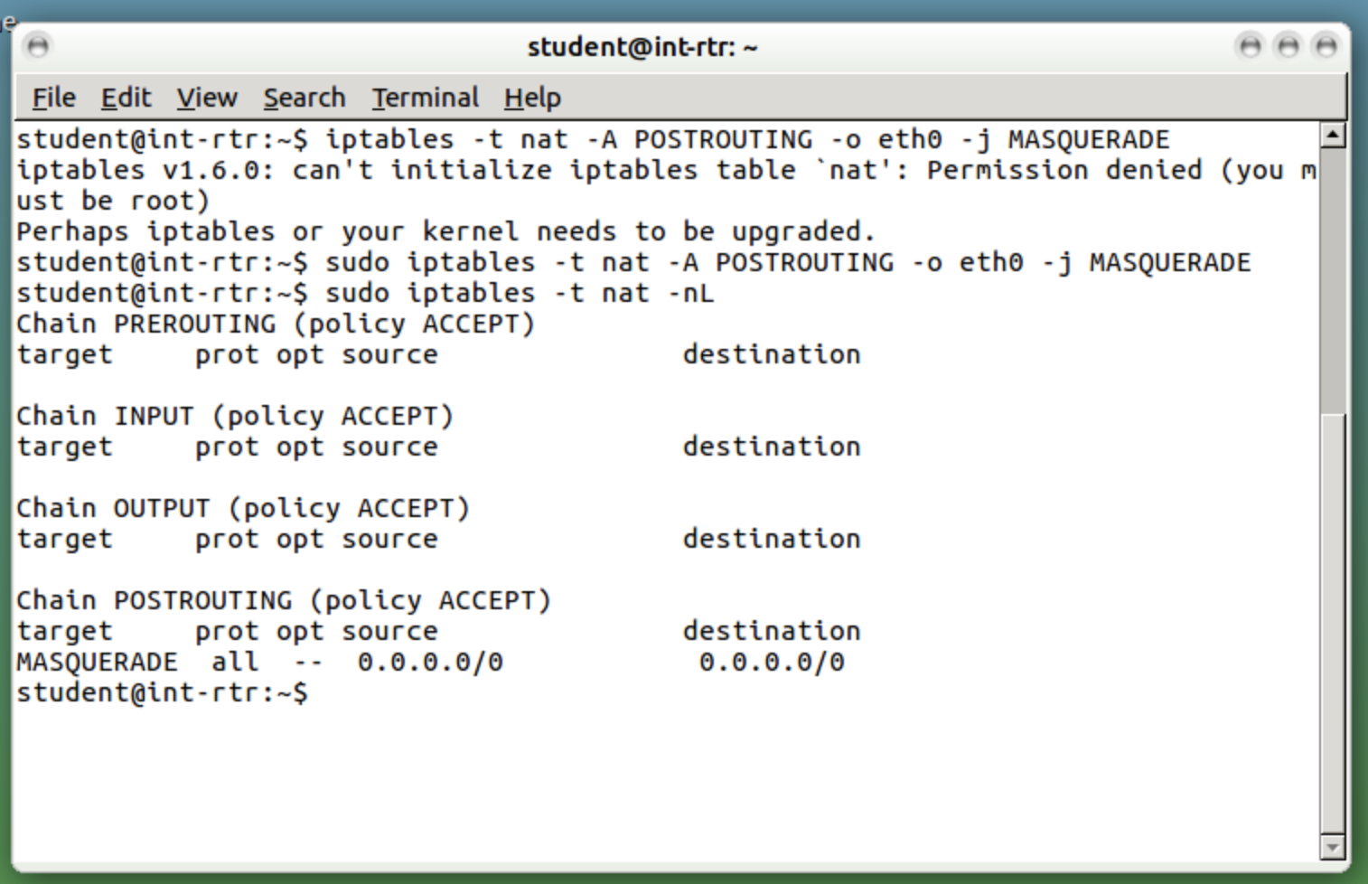

PINGING KALI LINUX MACHINE:

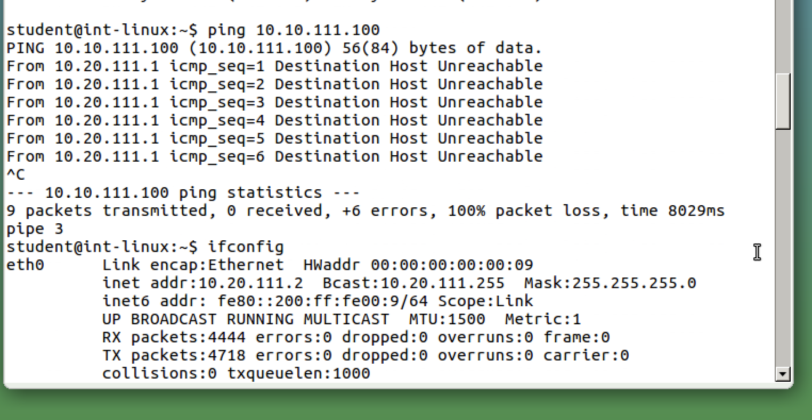

Kali Linux Wireshark

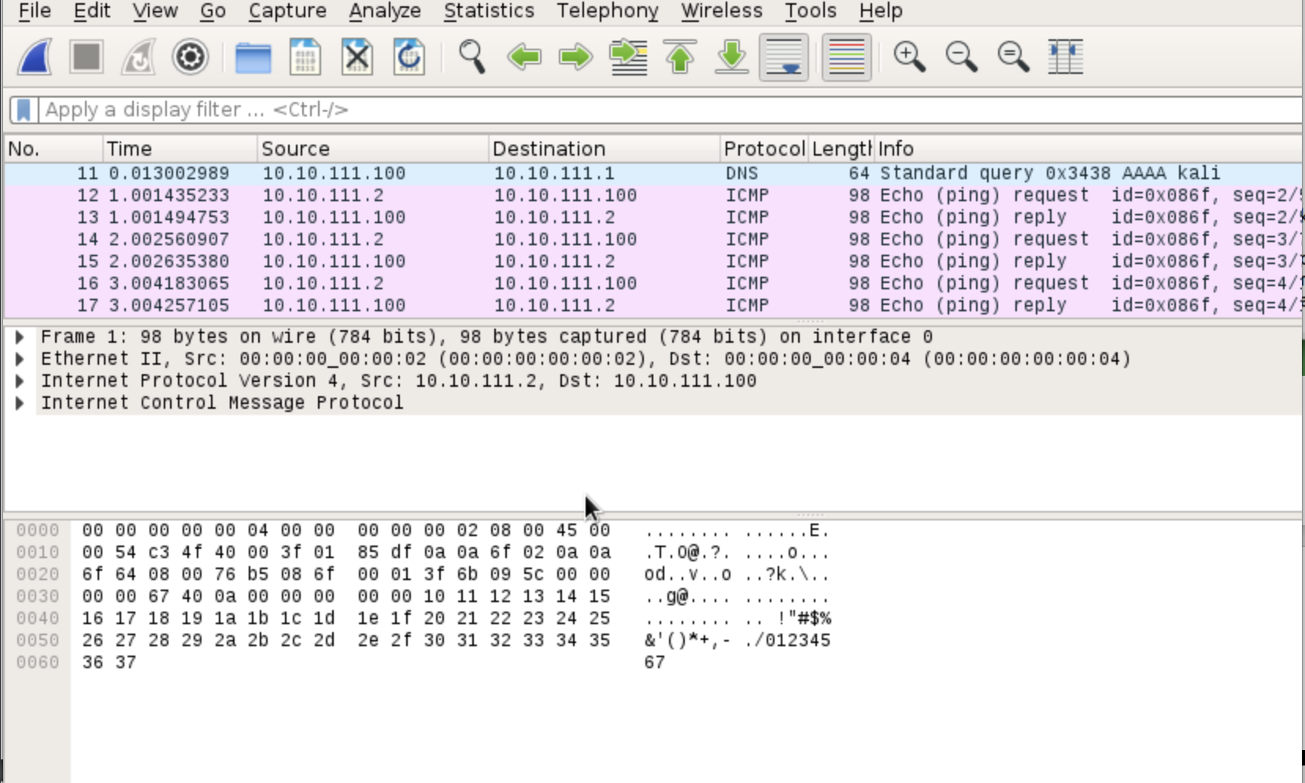

Shows IP as 10.10.111.1 when IP is 10.20.111.1

Ssh

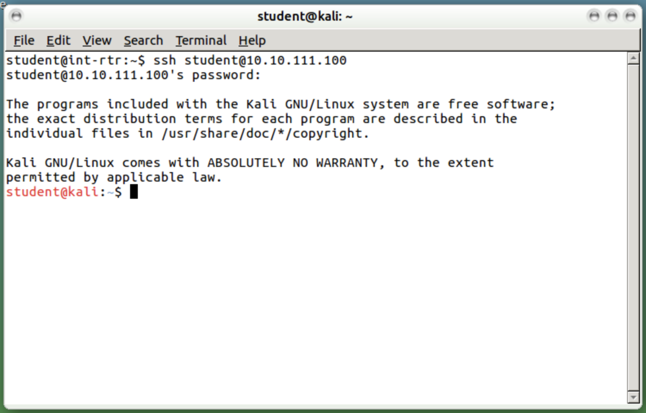

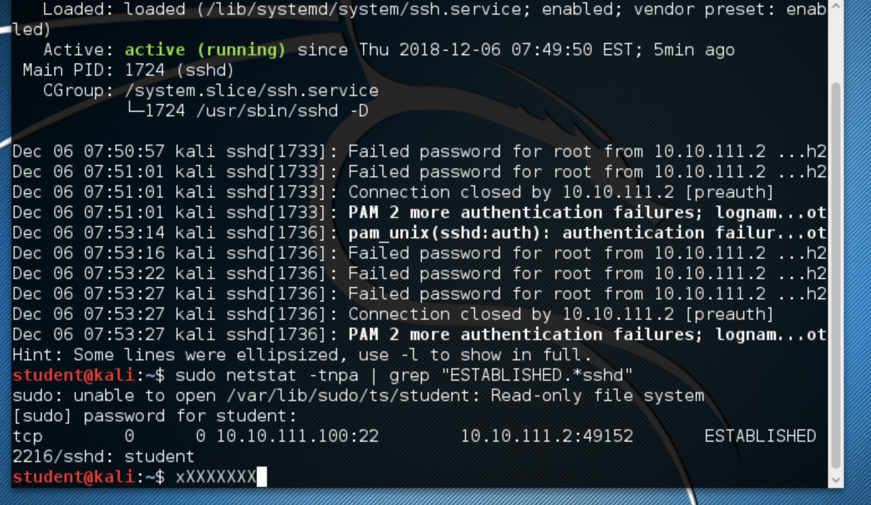

PART C:

What is the difference between input, output, and forward chains?

**All three, input, output, and forward chains, are a set of rules that the firewall uses to determine whether network traffic should be accepted or dropped. The difference in these chains is the source and destination of the packets. The input chain is the set of rules that is used when incoming packets have a destination of the actual computer or firewall; packets that are meant to be received by the actual computer. The output chain is used when the source address is the actual computer or firewall; packets that are created by the computer and are being sent out. Finally, the forward chain is when neither the source or destination is the computer; packets that are just passing through.**

What is the difference between reject and drop?

**Both reject and drop deny the request and packet. However, in a reject, the packet is not let through and a ICMP reject is sent back. In a drop, the packet is not let through and nothing is returned.**